# Experiment: Magnetic field-Distance Relationship Time allocated: 45 min

**Background Information:**

The magnetic flux density ($B$) is the strength of a magnetic field at a point in space measured in teslas (T). Along the long axis of a bar magnet, the magnetic flux density can be determined using the following expression:

$$B=\frac{μ_{0}M}{2πd^{3}}$$

Where:

$B is the magnetic flux density (T)$

$μ_{0} is the magnetic constant (m kg s^{-2} A^{-2})$

* $M is the magnetic moment of the bar magnet$ ($N m T^{-1}$)

$d is the distance from the middle of the bar magnet (m)$

$$d$$

Bar Magnet

The magnetic moment (M) of a bar magnet is a measure of the magnet’s intrinsic strength; it determines the force that the magnet can exert on other magnets. A larger magnetic moment indicates a stronger bar magnet.

The magnetic flux density for a bar magnet is proportional to $\frac{1}{d^{3}}$. The strengths of other types of fields in Physics covered in this course (gravitational and electrical) are proportional to $\frac{1}{d^{2}}$. Electric and gravitational fields can be produced from point source; a single point in space which can be considered as the source of the field (e.g. proton for electric fields or the centre of mass for a gravitational field). Magnetic fields are produced in a dipole arrangement; the separated N pole and S pole work together to produce the field. As long as the distance $d$ is significantly large compared to the length of the magnet, such that both poles contribute a similar amount to the magnetic field, this dipole arrangement is the reason why the flux density-distance relationship for magnetic fields is different to electric and gravitational fields of a point source.

**The Experiment:**

Students performed an investigation to check the relationship between the flux density and the distance from a bar magnet by using the following procedure:

1. *Place a magnet standing upright on a flat surface, with the N pole at the top.*
2. *Have a student hold a ruler close to, but not touching, the top of the magnet, aligned vertically.*
3. *Have another student use a magnetic probe to measure the flux density at the 10 cm mark of the ruler.*
4. *Repeat step 3, increasing the distance each time.*

Here is the students’ table of results:

|  |  |  |  |
| --- | --- | --- | --- |
| Distance from top of magnet (m) | Distance from middle of magnet (m) | Magnetic flux density (mT) |  |
| 0.060 | 0.100 | 170 |  |
| 0.080 | 0.120 | 100 |  |
| 0.110 | 0.150 | 50 |  |
| 0.140 | 0.180 | 30 |  |
| 0.180 | 0.220 | 16 |  |

**Questions**

1. Produce a linear graph from the independent and dependent variables in the table, using the background information as a guide. You may need to adjust the data to ensure the graph is linear. You may fill in the blank column of the table to assist you. [7 marks]

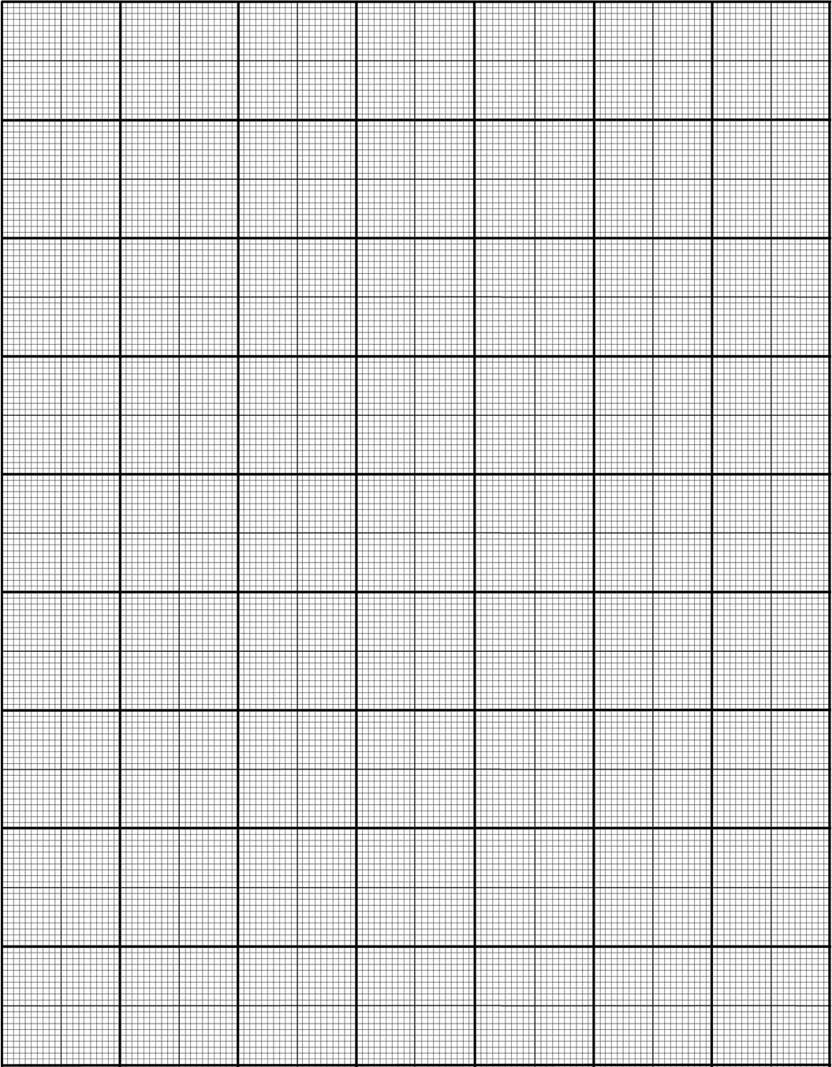

1 each for:

Title

Both axes labelled

Both axes units included

Plotted against 1/d^3

Used distance to middle (not top) of magnet

Accuracy of points

Suitable line of best fit and good scale

1. Describe what knowledge has been gained by producing a linear graph from manipulated data, compared to plotting the raw results. [1 mark]

The linear graph confirms the relationship that magnetic flux is proportional to the inverse of distance cubed (1)

1. From the graph, calculate the gradient of your line of best fit. Include units. [3 marks]

Uses a suitable calculation (rise/run or similar) (1)

Uses points from the graph, not from the table (1)

Includes units ($mT{ m}^{3}$) (1)

Answer is approximately $0.17 mT m^{3}$ (may also have answer in T instead of mT)

1. Using the gradient, determine the magnetic moment of the bar magnet the students used in this experiment. [3 marks]

$gradient = \frac{μ_{0}M}{2π}$ (1)

$0.17×{10}^{-3}=\frac{4π×{10}^{-7}×M}{2π}$ (must convert gradient value from mT to T)

$M=850 N m T^{-1}$ (1-2)

1. The students repeated the experiment with a different bar magnet that had twice the magnetic moment of the original. Onto your graph, sketch the expected trend line that would be produced by using this new bar magnet. [2 marks]

Gradient is twice as steep (1), still originating from [0,0] (1)

1. Based on the method the students followed and the data provided in the table, estimate the uncertainty of their distance measurements. Justify your estimation. [3 marks]

±0.0005 m as this is half of the smallest interval (precision) of students’ ruler (1-2)

**OR**

±0.01 m (approx.) as the students were holding the ruler while attempting to line up a vertical distance by free hand. Due to unsteady hands and eye-balling the ruler alignment they were prone to being off with their measurements (1-3)

1. The students had extra data which they left out of their table as it did not fit the expected trend. Here is a scale diagram of the equipment for this particular result.

Magnetic Flux Probe

Connected to data logger

1 cm

N

8 cm

S

The results obtained are below:

|  |  |  |
| --- | --- | --- |
| Distance from top of magnet (m) | Distance from middle of magnet (m) | Magnetic flux density (mT) |
| 0.010 | 0.050 | 1700 |

* 1. **Via a calculation**, determine what the expected magnetic flux density is 1 cm above the magnet, as predicted by the other results of this experiment. Calculate the percentage difference between this expected result and the actual result taken from 1 cm above the magnet.

[3 marks]

Uses $d=0.05$ and the magnetic moment ($M$) from question 4 to perform:

$B=\frac{μ_{0}M}{2πd^{3}}≈1.4 T or 1400 mT$ (1-2)

$\% diff = \frac{1700-1400}{1400}×100 = 21\%$ (1)

Note: allow students to use either value in the denominator of % difference.

* 1. This result is actually much closer to what would be expected if magnetic fields behaved the same way as electric and gravitational fields produced by a point source. Explain why. [3 marks]

The distance from the magnet is not sufficiently large compared to the length of the magnet. (1)

The N pole will be contributing a lot more to the flux in this region compared to the S pole. (1)

This makes the N pole of the magnet behave more like a point source, behaving like an electric or gravitational field point source. (1)